

# Batch: B-1 Roll No.: 16010422234 Name: Chandana Ramesh Galgali

# Experiment No.: 03

**Aim:** To implement a database for relational model in experiment no. 2 using DDL statements (Virtual Lab).

**Resources needed:** PostgreSQL PgAdmin4

# Theory:

The Data Definition Language (DDL) is used to create and modify the relational schema. Also it is used to add various constraints to the table like the primary key, foreign key, check constraint, not null constraint and unique constraint.

The DDL statements are: CREATE DROP ALTER

PostgreSQL supports the standard SQL types int, smallint, real, double precision, char(N), varchar(N), date, time, timestamp, and interval for creating tables.

# Procedure:

**Create Database and use it:**

$ createdb mydb

$ psql mydb

**Delete a database:** $ dropdb mydb

# Create table:

CREATE TABLE my_first_table ( first_column text,

second_column integer

);

CREATE TABLE products ( product_no integer,

name text, price numeric);

# Drop Table:

DROP TABLE my_first_table; DROP TABLE products;

# Default Value:

CREATE TABLE products ( product_no integer,

name text,

price numeric **DEFAULT 9.99** );

# Constraints:

1. **Primary Key**

CREATE TABLE products ( product_no integer **PRIMARY KEY**, name text,

price numeric );

Primary keys can also constrain more than one column. CREATE TABLE example (

a integer, b integer, c integer,

# PRIMARY KEY (a, c)

);

# Check Constraint

CREATE TABLE products ( product_no integer,

name text,

price numeric **CHECK (price** > **0)** );

# Not Null Constraint

CREATE TABLE products ( product_no integer **NOT NULL**, name text **NOT NULL**,

price numeric );

1. **Unique Constraint**

CREATE TABLE products ( product_no integer **UNIQUE**,

name text,

price numeric );

# Foreign Key Constraint

CREATE TABLE products ( product_no integer PRIMARY KEY, name text,

price numeric );

CREATE TABLE orders ( order_id integer PRIMARY KEY,

product_no integer **REFERENCES products (product_no)**, quantity integer );

Here a foreign key constraint in the order table references the products table.

# Modifying table:

**Adding column**

ALTER TABLE products ADD COLUMN description text;

# Removing column

ALTER TABLE products DROP COLUMN description;

# Adding Constraint

ALTER TABLE products ADD CONSTRAINT some_name UNIQUE (product_no); ALTER TABLE products ADD FOREIGN KEY (product_group_id) REFERENCES product_groups;

# Removing Constraint

ALTER TABLE products DROP CONSTRAINT some_name;

# Adding Not Null Constraint

ALTER TABLE products ALTER COLUMN product_no SET NOT NULL;



# Removing Not Null Constraint

ALTER TABLE products ALTER COLUMN product_no DROP NOT NULL;



# Results: (Queries printout with output)

*Query:*

Aviation_Services(Unique_Service_ID,Vegetarian_Meal,Non_vegetarian_Meal,Lounge_Services,Buggy_Services,Wheelchair,Medical_Help)

Airport(Unique_Service_ID,Airport_Name,Airport_Location,Number_Of_Runways)

Airline(Unique_Service_ID,Airline_Name,Country_Of_Origin,Fleet_Size)

Aircraft(Aircraft_ID,Engine_Design,Manufacturer)

Operated_By(Aircraft_ID,Airline_Name)

Aircraft_Model(Aircraft_ID,Model_ID,Aircraft_Model)

Flights(Unique_Service_ID,Flight_ID,Arrival_Time,Departure_Time,Arrival_Location,Destination,Aircraft_Used)

Passenger(Passenger_ID,Password,Name,DOB,Email,Address,Account_Number,Account_Type,Bank_Name

Used_By(Passenger_ID,Flight_ID)

Mobile_Number(Passenger_ID,Mobile_Number)

Tickets(Passenger_ID,Ticket_ID,Flight_Number,Seat_Number,Seat_Type,Price)

create table Aviation_Services(

Unique_Service_ID int primary key,

Vegetarian_Meal char(5),

Non_vegetarian_Meal char(5),

Lounge_Services varchar(20),

Buggy_Services char(5),

Wheelchair char(5),

Medical_Help varchar(20)

);

select * from Aviation_Services

create table Airport(

Unique_Service_ID int,

Airport_Name varchar(20),

Airport_Location varchar(20) NOT NULL,

Number_Of_Runways int check(Number_Of_Runways>=1),

primary key(Unique_Service_ID,Airport_Name),

foreign key (Unique_Service_ID) references Aviation_Services(Unique_Service_ID)

);

select * from Airport

create table Airline(

Unique_Service_ID int,

Airline_Name varchar(20),

Country_Of_Origin varchar(20),

Fleet_Size int check(Fleet_Size>=3),

primary key(Unique_Service_ID,Airline_Name),

foreign key (Unique_Service_ID) references Aviation_Services(Unique_Service_ID)

);

select * from Airline

create table Aircraft(

Aircraft_ID int primary key,

Engine_Design varchar(20),

Manufacturer varchar(20)NOT NULL

);

select * from Aircraft

create table Operated_By(

Aircraft_ID int,

Unique_Service_ID int,

Airline_Name varchar(20),

primary key(Aircraft_ID,Unique_Service_ID,Airline_Name),

foreign key (Aircraft_ID) references Aircraft(Aircraft_ID),

foreign key (Unique_Service_ID,Airline_Name) references Airline(Unique_Service_ID,Airline_Name)

);

select * from Operated_By

create table Aircraft_Model(

Aircraft_ID int,

Model_ID int,

Aircraft_Model varchar(20) NOT NULL,

primary key(Aircraft_ID,Model_ID),

foreign key (Aircraft_ID) references Aircraft(Aircraft_ID)

);

select * from Aircraft_Model

create table Flights(

Unique_Service_ID int,

Flight_ID int,

Arrival_Time time NOT NULL,

Departure_Time time NOT NULL,

Arrival_Location varchar(20) NOT NULL,

Destination varchar(20) NOT NULL,

Aircraft_Used varchar(20)NOT NULL,

primary key(Unique_Service_ID,Flight_ID),

foreign key (Unique_Service_ID) references Aviation_Services(Unique_Service_ID)

);

select * from Flights

create table Passenger(

Passenger_ID int primary key,

Password varchar(20),

Name varchar(20)NOT NULL,

DOB date,

Email varchar(20) UNIQUE,

Address varchar(20),

Account_Number int UNIQUE,

Account_Type varchar(20)NOT NULL,

Bank_Name varchar(20)NOT NULL,

Flight_History varchar(20)

);

select * from Passenger

create table Used_By(

Passenger_ID int,

Unique_Service_ID int,

Flight_ID int,

primary key(Passenger_ID,Unique_Service_ID,Flight_ID),

foreign key (Passenger_ID) references Passenger(Passenger_ID),

foreign key (Unique_Service_ID,Flight_ID) references Flights(Unique_Service_ID,Flight_ID)

);

select * from Used_By

create table Mobile_Number(

Passenger_ID int,

Mobile_Number int UNIQUE,

primary key(Passenger_ID,Mobile_Number),

foreign key (Passenger_ID) references Passenger(Passenger_ID)

);

select * from Mobile_Number

create table Tickets(

Passenger_ID int,

Ticket_ID int,

primary key(Passenger_ID,Ticket_ID),

Flight_Number int NOT NULL,

Seat_Number int NOT NULL,

Seat_Type varchar(20)NOT NULL,

Price int NOT NULL,

foreign key (Passenger_ID) references Passenger(Passenger_ID)

);

select * from Tickets

create table Flight_Crew(

Member_ID int,

Unique_Service_ID int,

Flight_ID int,

primary key(Member_ID,Unique_Service_ID,Flight_ID),

Name varchar(20) UNIQUE,

Shift int check(Shift=1 or Shift=2),

foreign key (Unique_Service_ID,Flight_ID) references Flights(Unique_Service_ID,Flight_ID)

);

select * from Flight_Crew

ALTER TABLE Flight_Crew ADD COLUMN Role varchar(20);

ALTER TABLE Flight_Crew ALTER COLUMN Role SET NOT NULL;

select * from Flight_Crew

ALTER TABLE Flight_Crew DROP CONSTRAINT Flight_Crew_Shift_check;

ALTER TABLE Flight_Crew DROP COLUMN Shift;

select * from Flight_Crew

DROP TABLE Flight_Crew;

select * from Flight_Crew

*Output:*

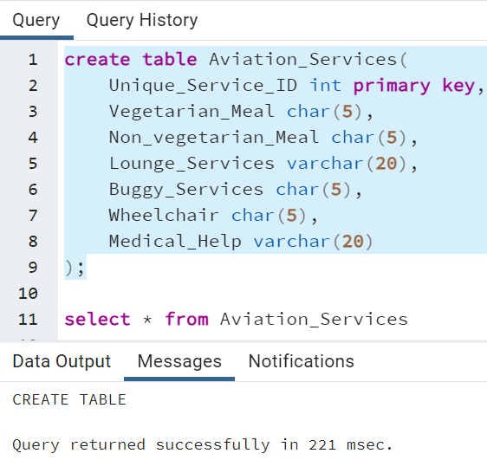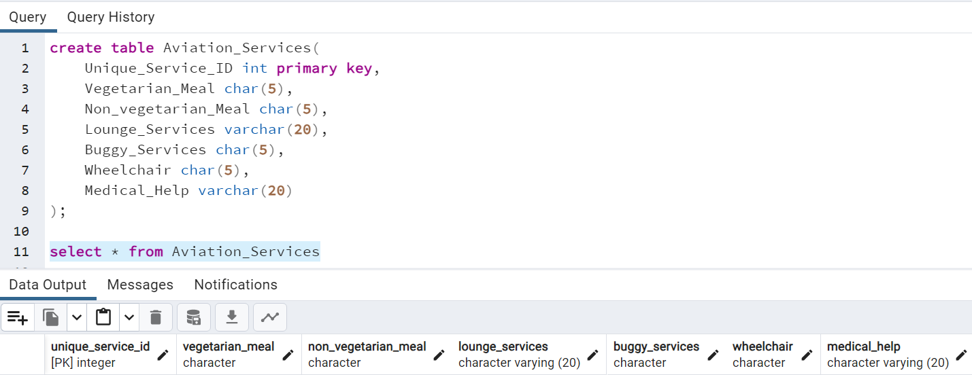

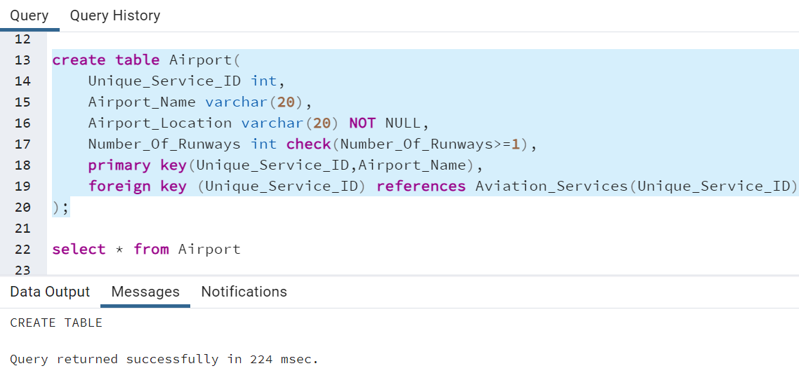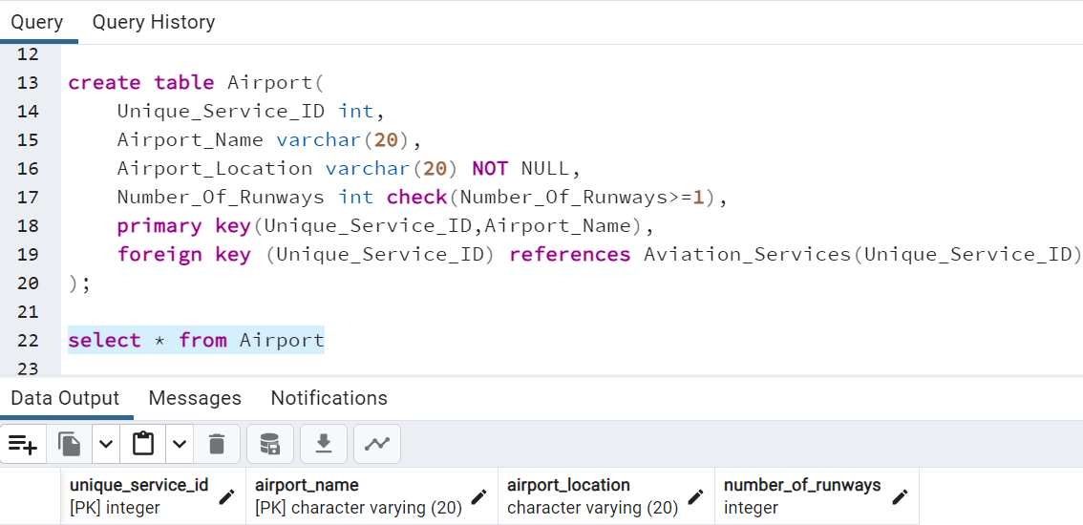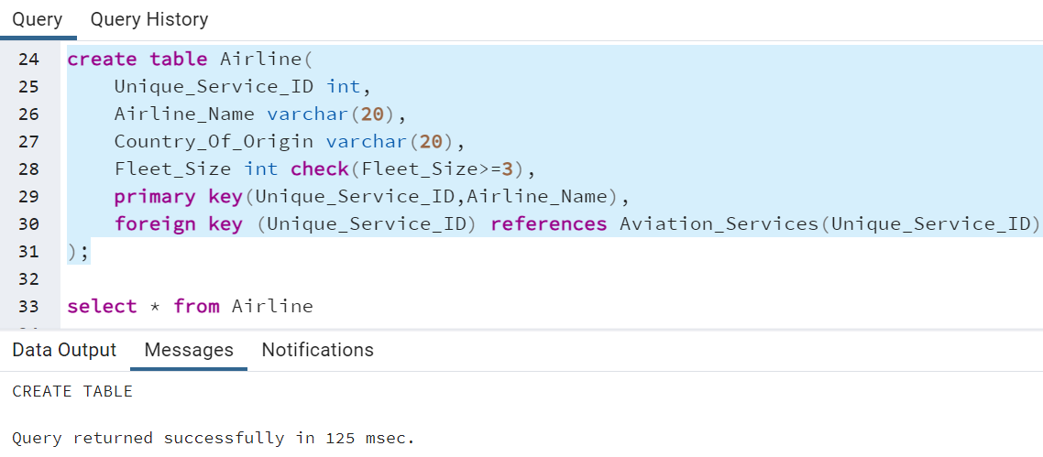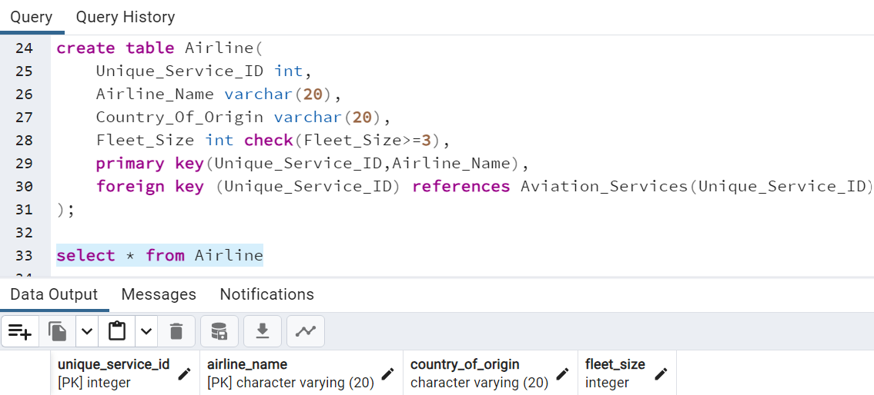

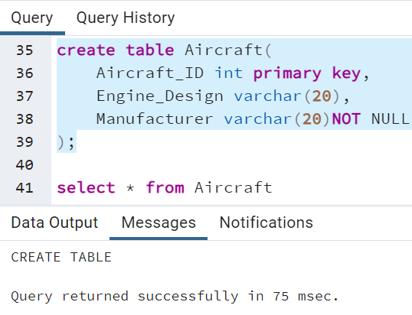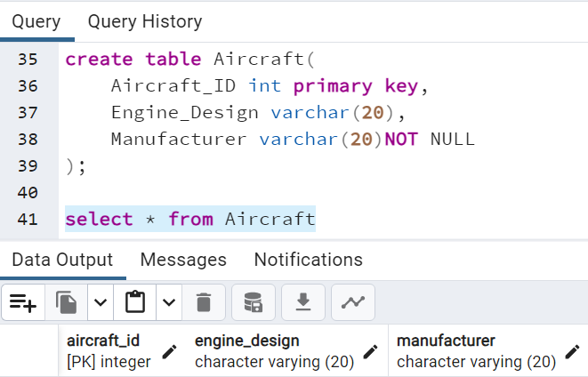

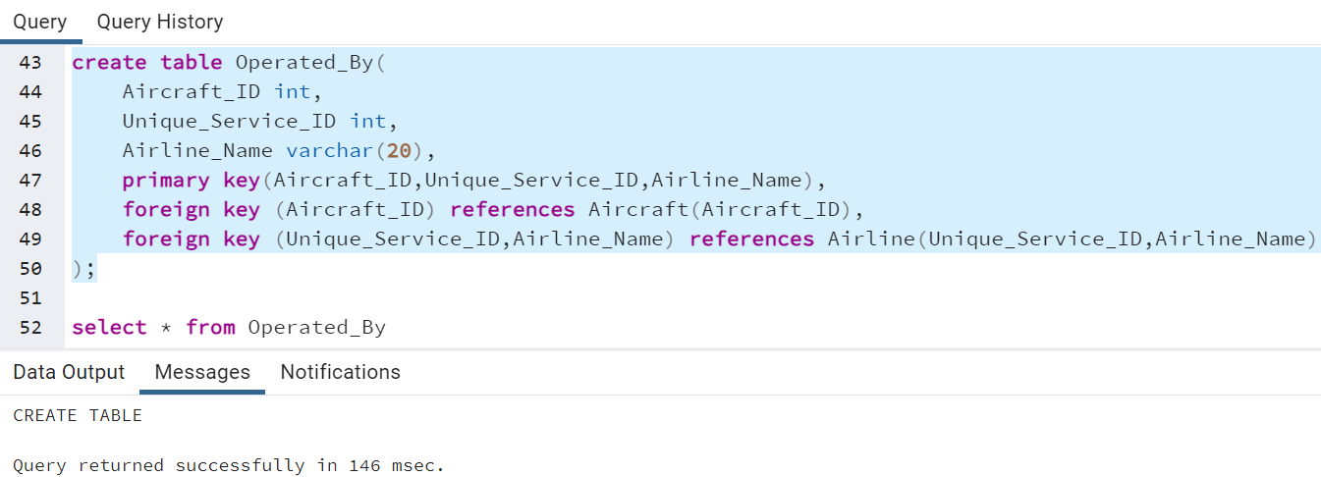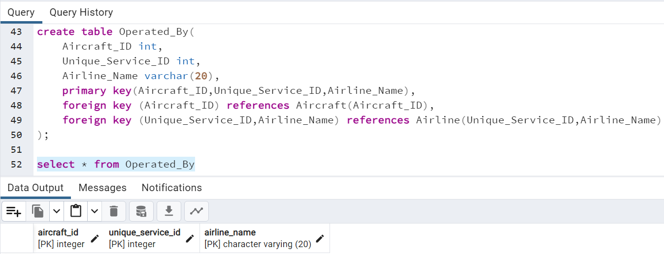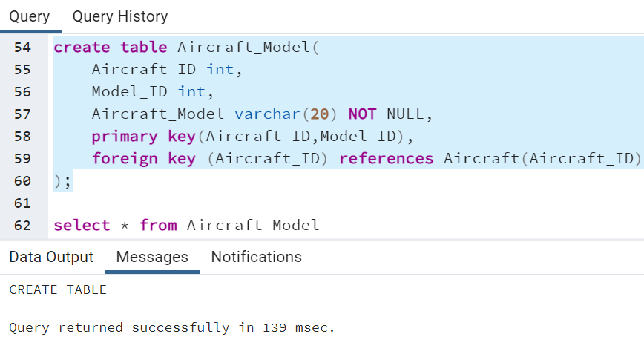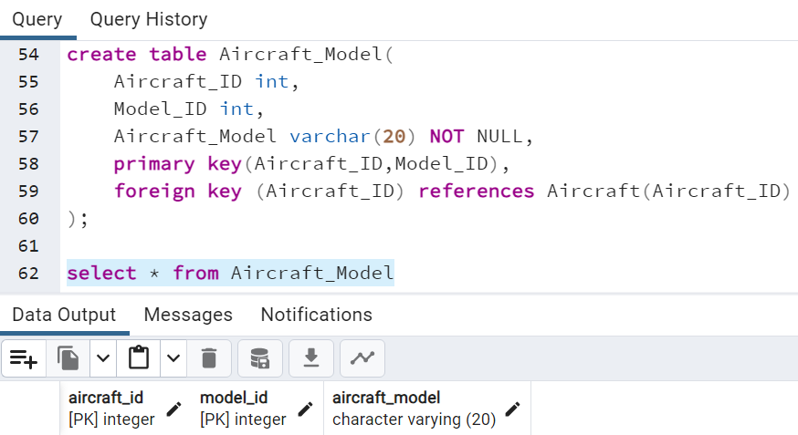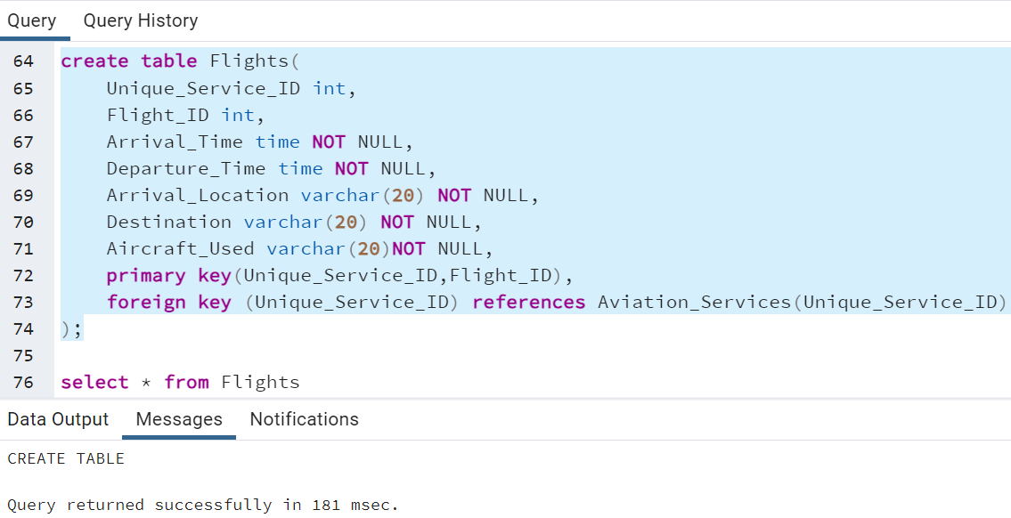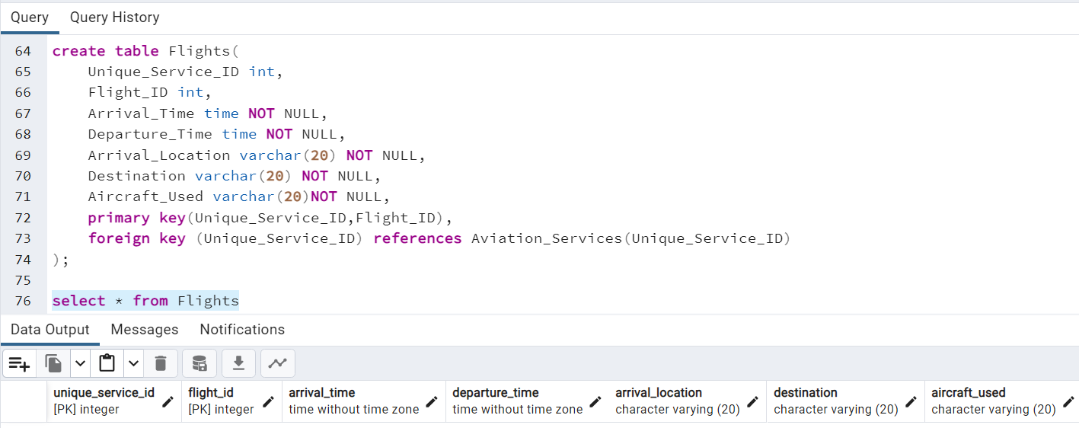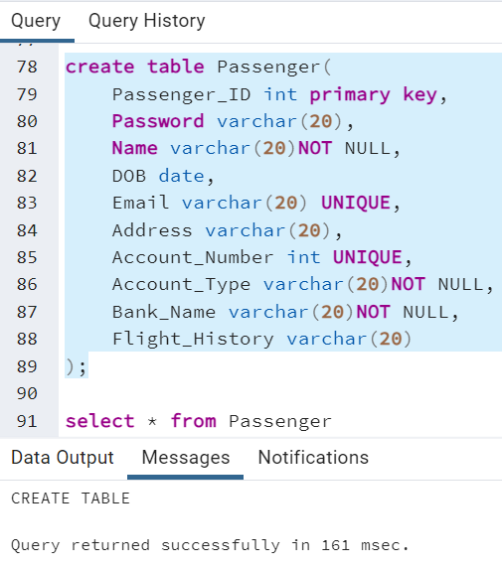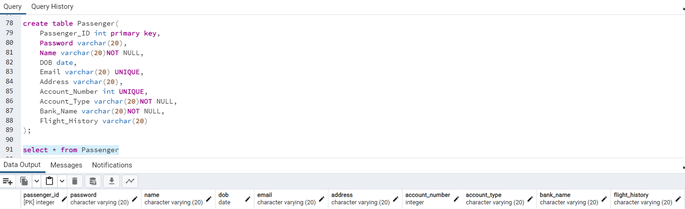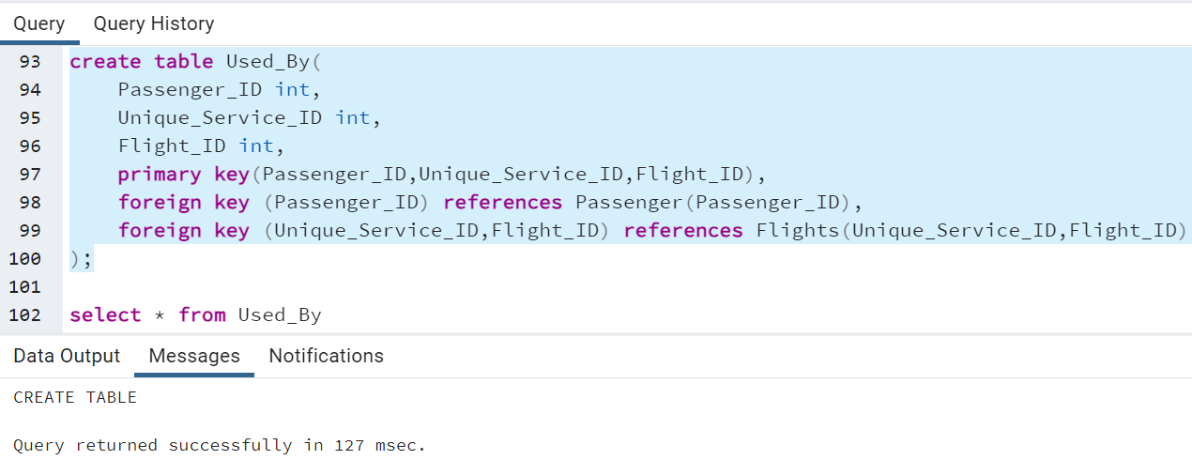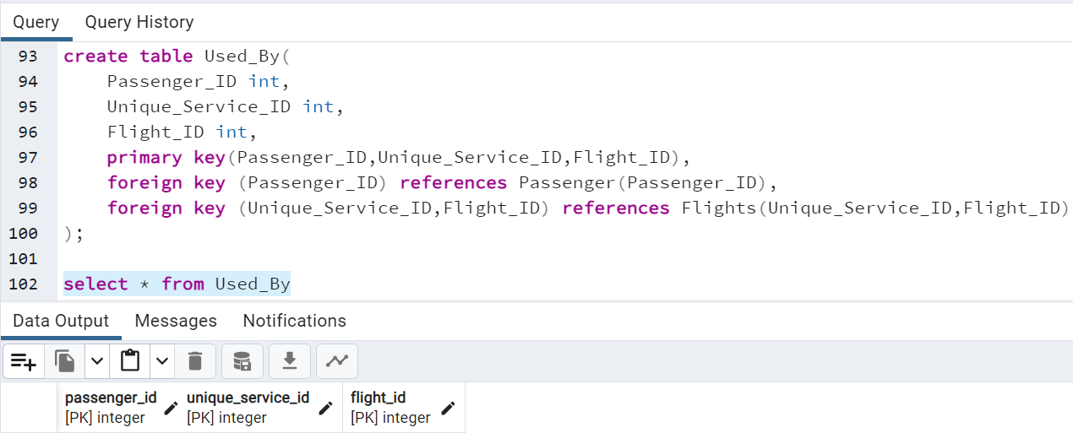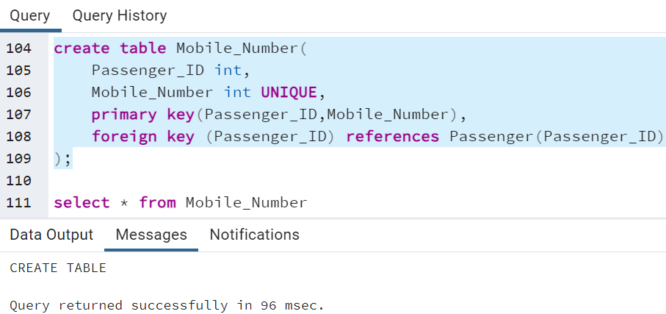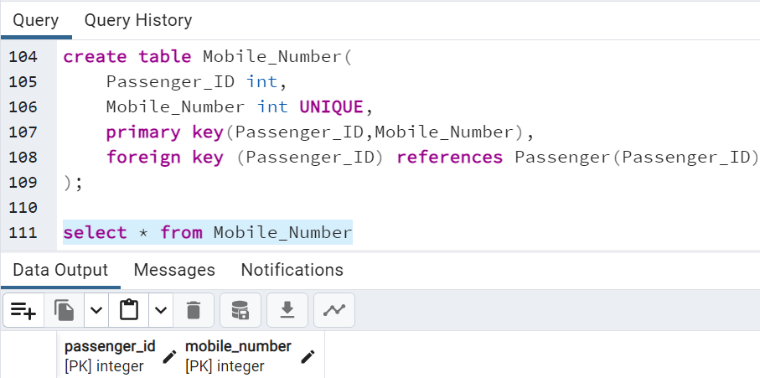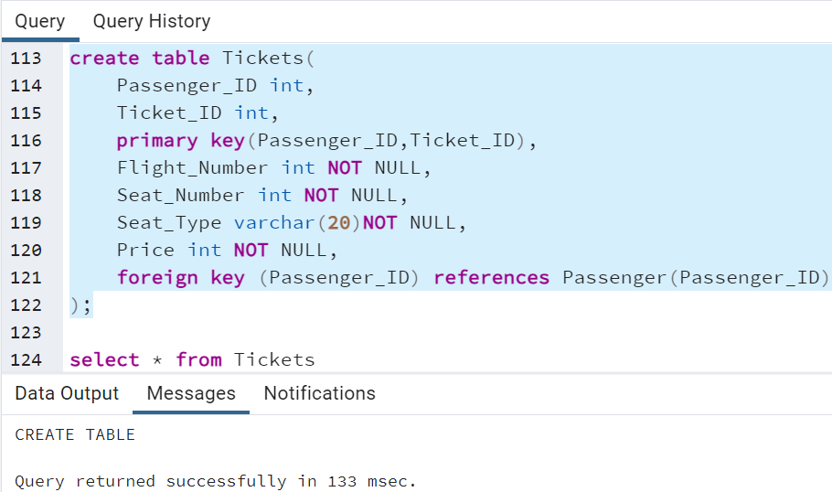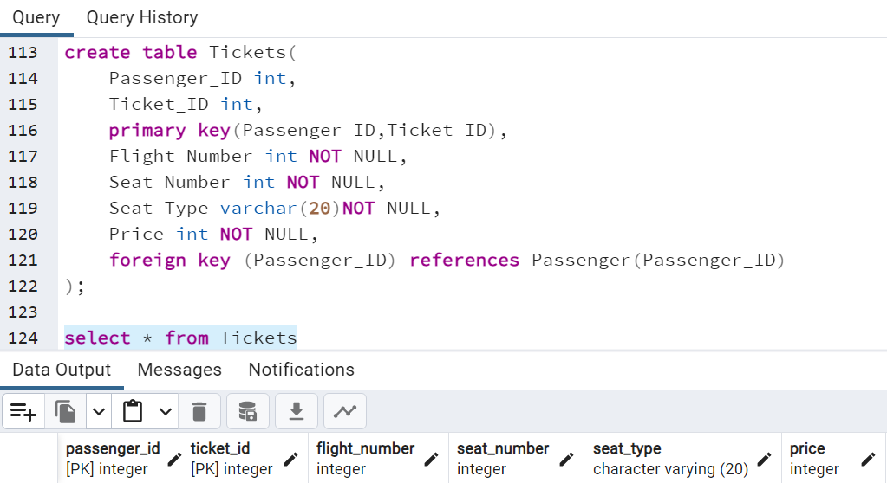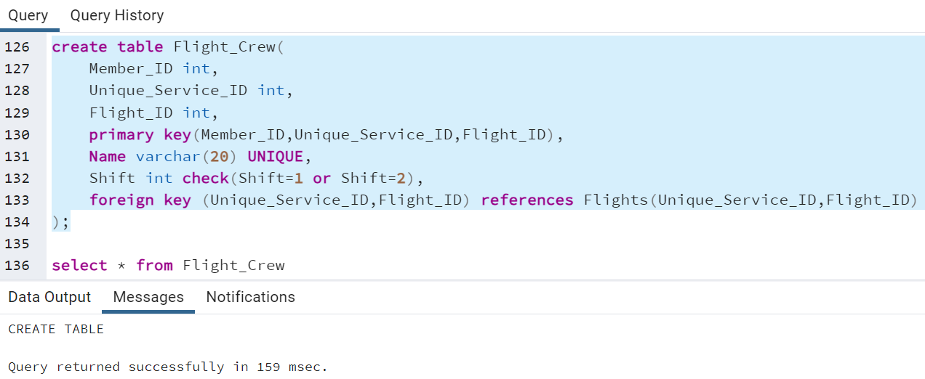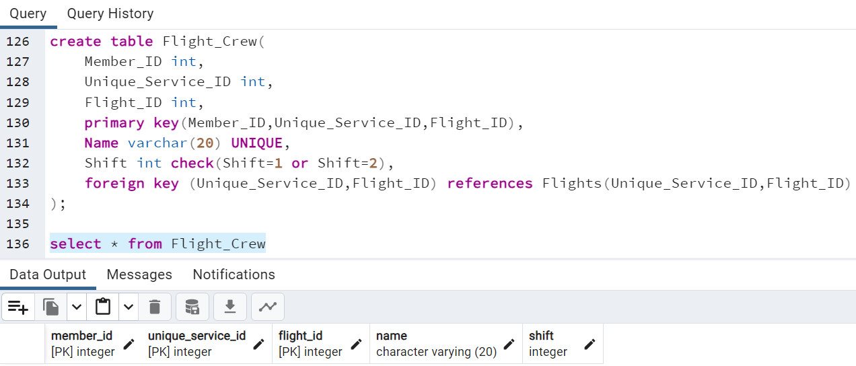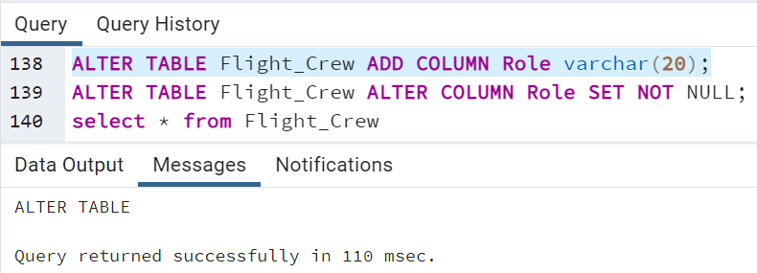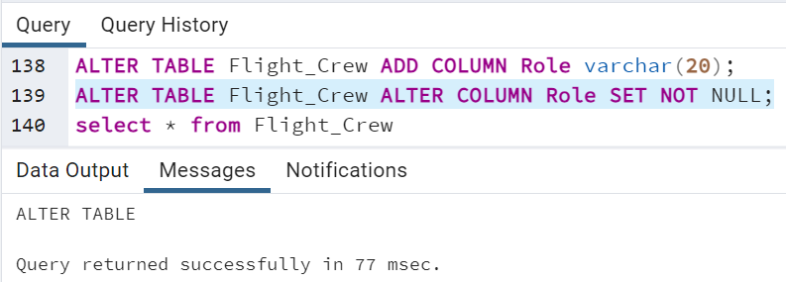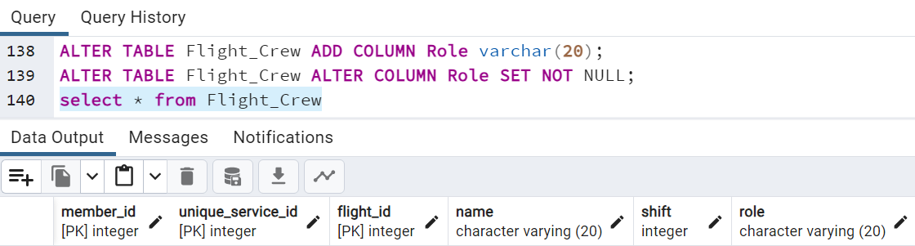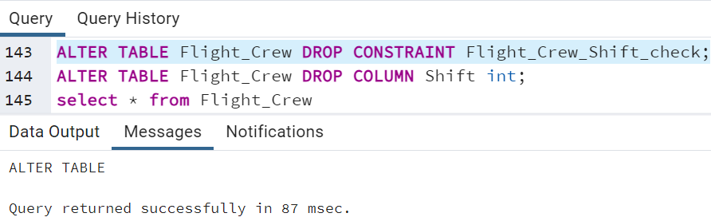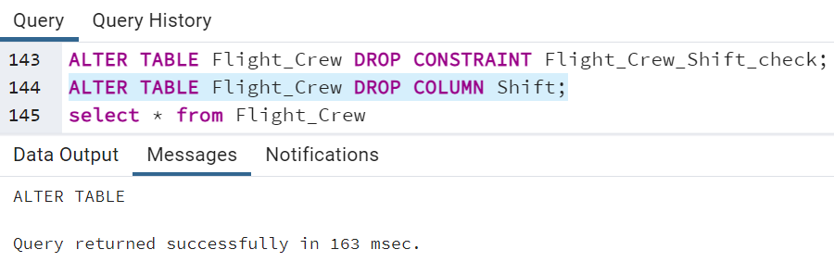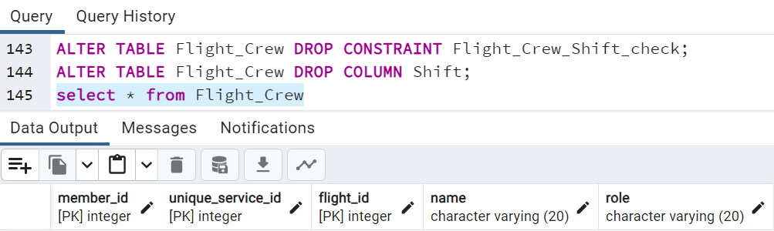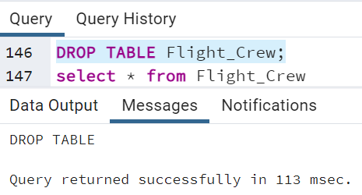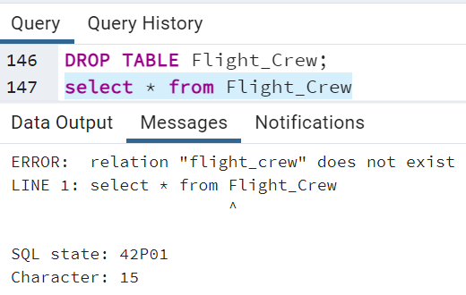

**Outcomes: Apply data models to real world scenarios.**



**Questions:**

**Q1 What is the difference between Truncate, Drop and Delete? Explain with examples.**

**Ans:** Truncate: The "truncate" operation is used to remove all the data from a table, effectively resetting it to its initial state. It is a fast operation because it deallocates the data pages used by the table, rather than deleting individual rows. Truncate also resets any auto-incrementing identity columns or sequence values. However, it cannot be rolled back, and it requires the user to have the necessary permissions.

Example: Let's say we have a table called "Customers" with multiple rows of data. If we execute the truncate operation on this table, all the rows will be removed, and the table will be empty.

Drop: The "drop" operation is used to remove an entire table from the database schema. It not only removes the data but also permanently deletes the table structure, including any associated indexes, constraints, and triggers. This operation is non-recoverable, and it also requires the necessary permissions.

Example: Suppose we have a table called "Products" that contains information about various products. If we execute the drop operation on this table, the entire table will be deleted, and it will no longer exist in the database.

Delete: The "delete" operation is used to remove specific rows from a table based on specified conditions. It allows for selective removal of data, unlike truncate, which removes all rows. Delete is a slower operation compared to truncate because it logs each row deletion and can be rolled back if necessary. It also triggers any associated delete triggers.

Example: Consider a table called "Employees" with multiple rows of data. If we execute the delete operation with a condition like "WHERE Salary < 5000," it will remove only those rows where the salary is less than 5000, leaving the rest of the data intact.

In summary, truncate removes all data from a table, drop deletes the entire table structure, and delete selectively removes rows based on specified conditions.



**Conclusion:**

We could successfully implement a database for the relational model using Data Definition Language (DDL) statements. The experiment involved creating tables, defining relationships between tables, specifying constraints, and setting up the necessary database structure.

**Grade: AA / AB / BB / BC / CC / CD /DD** 

**Signature of faculty in-charge with data**

**Reference books:**

1. Elmasri and Navathe, “Fundamentals of Database Systems”, 6th Edition, Pearson Education
2. Korth, Slberchatz,Sudarshan, :”Database System Concepts”, 6th Edition, McGraw – Hill.

# WebSite:

1. <http://www.tutorialspoint.com/postgresql/>
2. [http://sage.virtual-labs.ac.in/home/pub/21](http://sage.virtual-labs.ac.in/home/pub/21/)